W228A/1204C, W228B/1204C



DUBLIN INSTITUTE OF TECHNOLOGY
_____________

DT228A/1 MSc in Computing
DT228B/1 MSc in Computing
______________

SAMPLE
______________

Probability and Statistical Inference [Math9100]

Ms. deirdre Lawless
Dr. Deirdre Lillis

Two Hours

SAMPLE PAPER

Instructions to candidates

Answer question one and one other question.

All questions carry equal marks.

1. |  | A researcher wants to investigate lecturer salaries in Ireland. They have developed a theory as part of their research that there is a correlation between years of experience and salary earned. Further they theorize that there is a difference in salary based on gender. Their intention is to conduct a statistical analysis of this dataset so that they can extrapolate their findings to all major universities in Ireland.  A dataset comprising 52 cases, each representing a single lecturer, was constructed by conducting an audit of lecturing staff in a single college within a single university located in the capital city by surveying lecturing staff scheduled to work on a single day. The variables collected are described in the table below. The university has 8 colleges and has 400 lecturing staff. There are currently 15 major universities operating in the country of similar scale, three located in the capital but all others located in areas that significantly smaller population sizes than the capital city. The gender ratio in lecturing staff in the country is 70:30 male:female. Missing data is not a concern.  Traditionally a 5% cut-off level of statistical significance is used within the research domain
  Variables of concern in the dataset
  Name | Label | Values | Type
  Salary | Annual Salary |  | Scale
  Gender | Gender | 1=Female, 2=Male | Categorical
  Exper | Years of experience |  | Scale
  ZSalary | Standardised score for salary |  | Scale
  ZExper | Standardised score for experience |  | Scale
Question One continued on next page

 | (a) | Discuss the suitability of the dataset collected for use in the proposed research.  Comment in particular on the representativeness of the sample and consider the concepts of statistical significance and the role probability plays in this, statistical power, Type I and Type II errors. Identify mechanisms that the researcher could use to address issues you identify.  (15 marks)
 | (b) | - Examine the information provided on the variables included in the dataset.  Using the information provided in Appendix A, discuss their central tendency, dispersion, in particular skewness and kurtosis. Explain each concept and discuss their impact on the proposed research as well as mechanisms that could be used to address issues identified so that the data could be used in the proposed research.  Illustrate your answer with reference to the statistics and graphs provided in Appendix A.  (15 marks)  - Explain the steps that the researcher should take in developing and testing their hypotheses.  Using you answer to part (a) and part (b) (i) you should conclude whether you parametric or non-parametric tests are suitable for use in this research.  (10 marks)
 | (c) | Explain the goal of statistical tests. Illustrate your answer by using the results of the relevant test provided in Appendix A, to interpret the relationship between years of experience and salary, and the difference in salary based on gender.  (10 marks)

Q1 | Marking/Expected Answer
(a) | 4 x 2 marks Explanation of statistical significance and relationship with probability and Explanation of statistical power;  6 marks discussion of representativeness and ways to correct (3 marks for issues, 3 for solutions)  1 mark overall cohesive answer  Sig: means the statistic is reliable to cut-off level can conclude level of evidence to reject null hypothesis to this level e.g. 5%=p value 0.05 ; p value is the probability value is the probability of an outcome given the hypothesis  Power: probability of correctly rejecting a false null hypothesis; sample size is key possible in small sample size that even a fairly large population difference would be difficult to detect and no strong conclusions can be drawn about the population; expect consideration of dataset size provided  Type I: incorrect rejection of correct null hypothesis  Type II: failure to reject null hypothesis  Representativeness: Size of dataset is an issue; method of sample collection is an issue; gender representation an issue; Potential solution – weighting for non-response, weighting for design effect, should recognise scaling up for population is not appropriate
(b) | (i)  4 x 3 marks for correct central tendency and spread of each variable plus skew and kurtosis  3 marks discussion of consequences of skew and kurtosis  Central tendency: single value that attempts to describe a set of data by identifying the central position within that set of data. Expect brief discussion of Mean, Median, Mode  Dispersion: how the data is dispersed around the central measure; Expect brief discussion of standard deviation, interquartile range, range.  Skewness: measure of the asymmetry of the probability distribution – source of bias; discuss skewness statistic; acceptable range +/-2;  Kurtosis: measure of whether the data are peaked or flat relative to a normal distribution – source of bias; should discuss kurtosis statistic; acceptable range +/-2 – should identify kurtosis of length of stay
(b) | (ii)  3 marks discussion of steps of hypothesis testing:  3 marks Correct hypotheses pairs  4 marks link to previous answers with conclusion  Hypothesis testing steps: Derive null and alternate hypotheses; identify type of test needed based on hypothesis; decide on cut-off and critical value; conduct the test to compute test statistic; interpret statistical significance and test statistic; conclude on whether to accept/reject null hypothesis.  H0: There is no relationship between salary and experience/Ha: there is a relationship; H0: there is no difference in the relationship between salary and experience for different genders/HA: there is a difference  Sig:; means the statistic is reliable to cut-off level can conclude level of evidence to reject null hypothesis to this level e.g. 5%=p value 0.05 ; p value is the probability value is the probability of an outcome given the hypothesis  Power: probability of correctly rejecting a false null hypothesis; sample size is key possible in small sample size that even a fairly large population difference would be difficult to detect and no strong conclusions can be drawn about the population; expect consideration of dataset size provided  Type I: incorrect rejection of correct null hypothesis  Type II: failure to reject null hypothesis
(c) | 4 marks goal of statistical tests and description of test statistic  2 x 3 marks for illustration of correlation and differences (choice depends on decision made in (b))  The basic goal of simple statistical tests is to show that the distribution of the given data under examination is not produced by chance and that there is some systematic pattern therein.  Test statistic (e.g. a z score) forms a ratio comparing the obtained difference between the sample and the hypothesized population versus the amount of effect or difference we would expect.

2. | (a) | The researcher decided to explore the relationship between salary, experience and gender.  The researcher first created a simple linear regression model including the standardised score for the years of experience as a predictor variable for the standardised score for salary.  Explain what linear regression will allow the researcher to do and what in this context prediction means. Illustrate your answer by using the additional statistics provided in Appendix B to state the regression equation, interpret the model and assess the fit and usefulness of the model considering the coefficients, R², Adjusted R²and F statistic.  (20 marks)
 | (b) | Differences in salary based on gender have been found. Suppose the researcher has extended the model to include gender by incorporating a dummy variable dummyGender which has a value 0 for male and 1 for female.  Explain clearly why a dummy variable is needed before using the information provided in Appendix B to state the regression equation, interpret this second model for both males and females, assess its fit and compare it to the model created in part (a).  (18 marks)
 | (c) | Three major concerns for multiple linear regression are multicollinearity, normality of the residuals and outliers.  Explain these concerns and why they are important. Illustrate your answer with reference to the model created for part (b) using the information provided in Appendix B.  (12 marks)

Q2 | Marking/Expected Answer
(a) | 2 marks explanation of what regression will allow researcher to do  2 marks explanation of what prediction is in this context  3 x 4 marks explanation and assessment of the coefficients, R2 and F statistic  4 marks statement of equation and correct interpretation of the model  Prediction: looking at is the variance in the outcome variable and how much of the variance could be considered to be explained by the predictor variables – should be applied to problem  Regression equation zsalary= b0 + b1* zexper  Coefficients: Measure the strength and direction of relationships between independent variables and the dependent variance – need to consider the significance of these  R2: the proportion of variance in the outcome (dependent) variable which can be explained by the predictor (independent) variables. An R2 of 1 means the independent variable explains 100% of the variance in the dependent variable. Conversely 0 means it explains none.  F statistic: Whether the model as a whole predicts the dependent variable  Its statistical significance is the significance of the model  Fit and usefulness: assessment of R2 and F plus co-efficients: model is statistically significant, experience is a significant predictor, explains x% of the variance  Interpretation: should consider increase in one unit of experience and its impact on salary
(b) | 3 marks explanation of dummy variable  3 marks correct assessment of model fit and usefulness of model, explains x%, model is significant  3 marks comparison with other model including any change in coefficient for TV hrs watched – no overall change in model but change in TV hrs coefficient which remains statistically significant  4 marks correct interpretation of coefficients and significance, gender not significant, coefficient of TV hrs changed  5 marks correct regression equation and application to male and female  Dummy variable: interested in effect of characteristic, if include 1 and 2 will act as multiplier, 0 and 1 can see effect and its absence  Assessment of fit and usefulness: Adjusted R2 and Fstat  Regression equation zsalary= b0 + b1* zexper+b2*dummygender  Should look at model for male and female
(c) | 3x 4 marks (2 marks explanation and importance, 2 marks illustration)  Multicollinearity: Occurs when two or more independent variables contain strongly redundant information; If variables are collinear then it means there is not enough distinct information in these variables for MLR to operate – they are essentially measuring the same thing; Examining a correlation matrix that compares your independent variables with each other; coefficient above 0.8 suggests collinearity might be present Consider: VIF = variance inflation factors - Tells you what the standard error would be if the variable was uncorrelated with others; Values of VIF that exceed 2.5 should be cause for concern; Tolerance – should be concerned if it is lower than 0.4. If it is a concern you need to analyse your variables in separate regression equations and then examine how they operate. Normality of residuals: Should follow a normal distribution with a mean of 0; Since the residuals measure where the points fall in relation to the regression line, a normal distribution of residuals indicates that the same number of points fall above and below the line; Look at histogram and residual statistics.  Outliers: MLR can be greatly influenced by outliers - They ‘pull’ the equation away from the general pattern  Sometimes it is reasonable to delete the outliers; Sometimes you need to retain the outlier – it may be your most important observation; Sometimes it is a good idea to do your analysis twice – once with and once without the outlier to see how much influence it is having on the model  Look at the Minimum and Maximum values next to Std. Residual (Standardised Residual) subheading. +/- 1.96 95%, +/- 3.29 99%  Cook’s distance: Measures the effect of deleting a case; Look at Cook’s distance for values greater than one

3. |  | A researcher has collected data on student attitudes about their university experience. They conducted a survey using a recognised attitudinal scale which has been found to be reliable. They wish to incorporate measures of student satisfaction with their experience without including all variables. They wish to conduct an exploratory factor analysis on these variables. The dataset contains 254 cases.  Explain clearly the objectives of exploratory factor analysis and principal component analysis. Explain the difference between them and when you would use each technique.  (15 marks)
  Variable Name | Label | Values
  att_1 | Attitude: Good standard of teaching | 1(Extremely Good) to 10 (Extremely Poor)
  att_2 | Attitude: Good value for money | 1(Extremely Good) to 10 (Extremely Poor)
  att_3 | Attitude: Good availability of staff | 1(Extremely Good) to 10 (Extremely Poor)
  att_4 | Attitude: Bills are clear | 1(Extremely Good) to 10 (Extremely Poor)
  att_5 | Attitude: Convenient Timetable | 1(Extremely Good) to 10 (Extremely Poor)
  att_6 | Attitude: Good university to be in | 1(Extremely Good) to 10 (Extremely Poor)
Discuss the suitability of the dataset and the reliability of the scale for use in exploratory factor analysis. Illustrate your answer with reference to the additional statistics and graphs provided in Appendix C.
(15 marks)
Suppose the researcher conducted an Exploratory Factor Analysis on these variables using Principal Axis Factoring as the extraction method and Varimax as the rotation.

Explain how factor analysis works focusing on extraction and loading. Illustrate your answer by interpreting the output of the factor analysis conducted for this research using the information provided in Appendix C.
(20 marks)

Q3 | Marking/Expected Answer
(a) | 2 x 4 marks objectives of EFA and PCA; 3 marks explanation of difference; 3 marks explanation of use  1 mark cohesive answer  Objectives: Reduce the number of variables; Evaluates the construct validity of a scale, test, or instrument; Development of parsimonious (simple) analysis and interpretation; Addresses multicollinearity (two or more variables that are correlated)  Differences/Use EFA and PCA: EFA Determine the nature of and the number of latent variables that account for observed variation and covariation among set of observed indicators; Used to develop theoretical constructs; Used to prove/disprove proposed theories; only shared variance is used; PCA Reduce multiple observed variables into fewer components that summarize their variance; All of the variance in the variables is used
(b) | 3 marks Sample size and sample to variable ratio (1 for explanation, 2 for interpretation); 5 marks Factorability of the correlation matrix (2 for explanation, 3 for interpretation); 4 marks Kaiser-Meyer-Olkin (KMO) /Bartlett's (2 for explanation, 2 for interpretation); 3 marks Reliability – Cronbach’s alpha (1 for explanation, 2 for interpretation)  Sample size, sample to variable: generally at least 300 cases needed; N:p ratio where N = no of cases, p=no of variables rule of thumb 10:1. Alternate rules may be accepted;  Factorability of the matrix: looking at relationships between individual variable; correlation coefficients >0.30 indicates that the factors account for approximately 30% relationship within the data, or in a practical sense, it would indicate that a third of the variables share too much variance – good indicator for EFA. If no correlations need to rethink use of EFA. Need to identify correlations  KMO proportion of variance in variables that might be caused by an underlying factor. High values close to 1 suggest that FA useful, anything less than 0.5 FA won’t be useful. Bartlett tests that variables are correlated. Looking for a statistically significant p value which suggests that they are related and a FA would be useful.  Reliability accuracy and precision of a measurement procedure; Cronbach’s alpha – index of reliability associated with the variation accounted for by the true score of the "underlying construct"; Acceptable level depend on the purpose of the instrument. Acceptable 0.60.
(c) | 4 marks extraction (1 for meaning, 2 for application)  2 marks rotation (2 for meaning)  4 marks communalities (2 for meaning, 2 for application)  4 marks variance (2 for meaning, 2 for application)  4 marks loadings (2 for meaning, 2 for application)  2 marks correct identification of factor  Extraction: aim is reduce a large number of items into factors. Need to decide how many factors to retain. Criteria for extraction: Kaiser’s criteria (eigenvalue > 1 rule), the Scree test, the cumulative percent of variance extracted.  Rotation: Unrotated results from a factor analysis are not easy to interpret, although the plot helps. Rotation helps clarify and simplify the results of a factor analysis. Conceptually, the axes are being rotated so that the clusters of items fall as closely as possible to them. Making the factor loading pattern much clearer as one of the two pairs of coordinates for each item tends to be close to 0.00  Variance: Looking at total variance explained for factors with eigenvalues > 1; factor 1-? explains x% of total variance; Rotation equalises the importance of the factors.  Communalities: proportion of the common variance within a variable; looking at extraction column  Should look at factor loadings before rotation and after to see difference  Should draw conclusions about the number of factors and variance explained

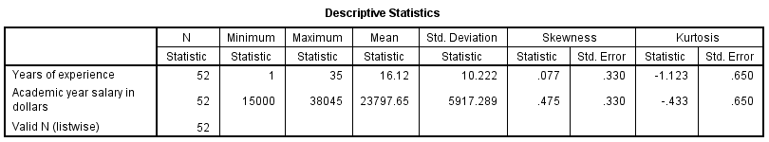
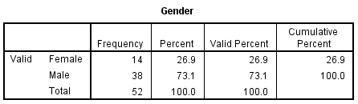
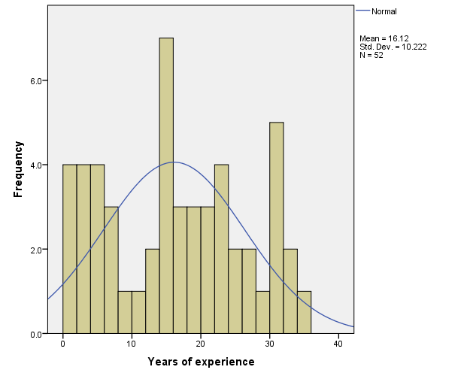 | 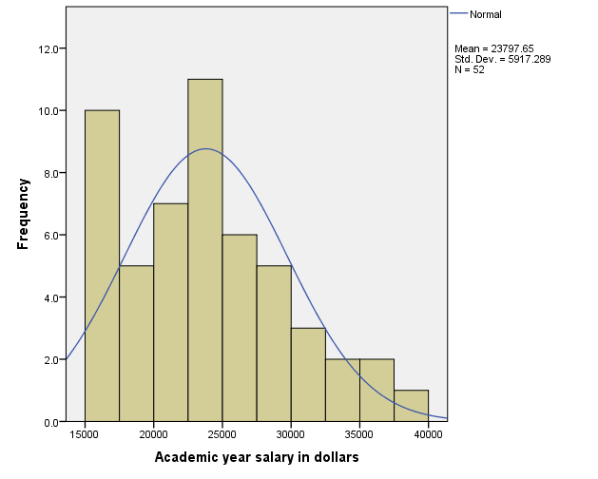

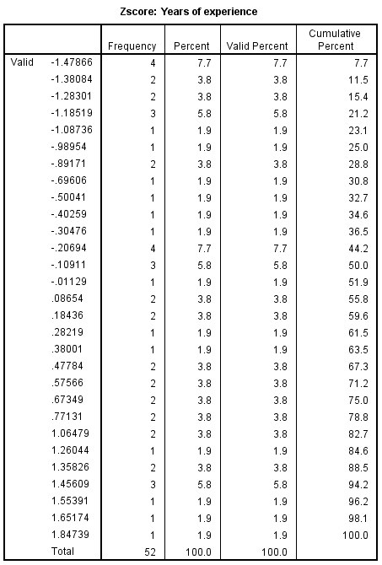 | 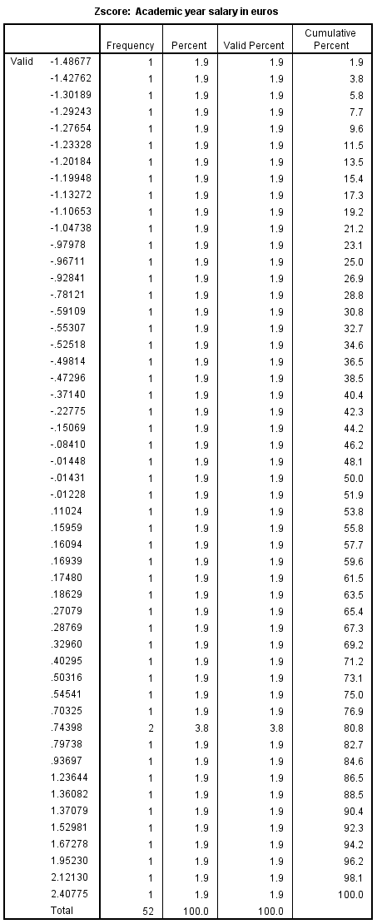
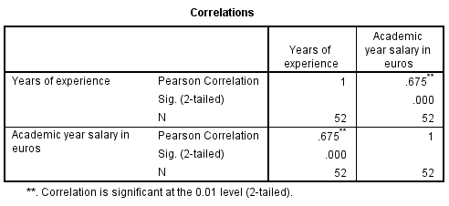 |  | 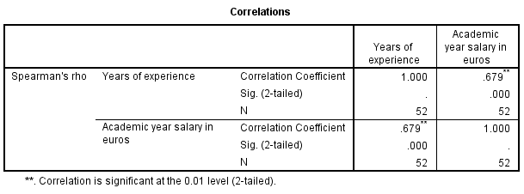
T-Test
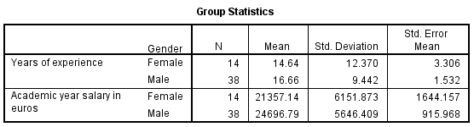
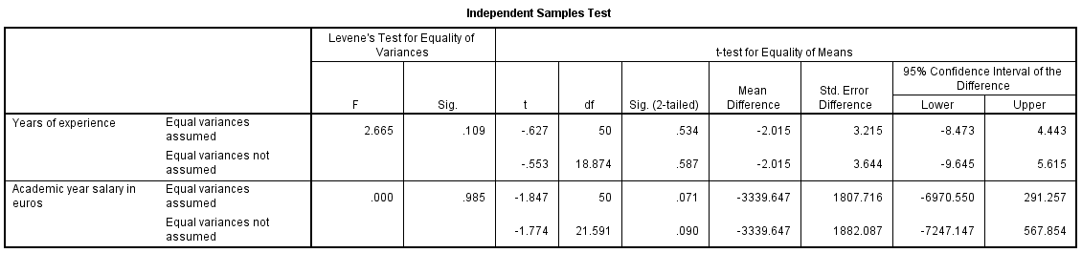
Mann-Whitney Test  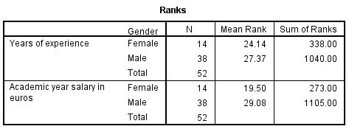 |  |  | 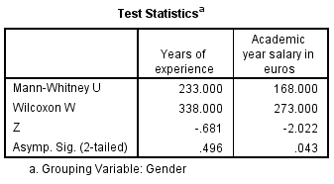

Model for Q2(a) |  |  | Model for Q2(b)
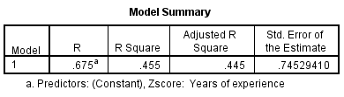 |  |  | 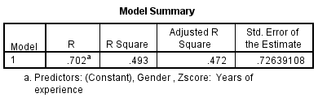
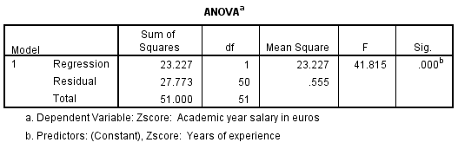 |  |  | 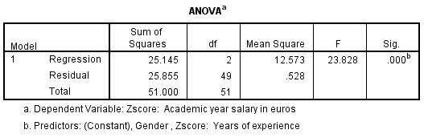
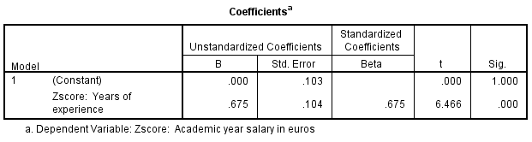
 | 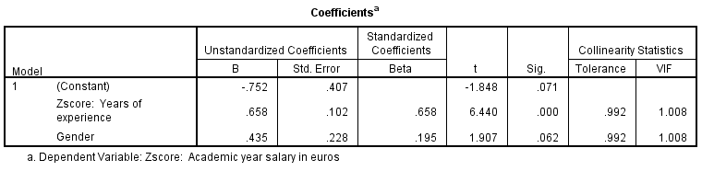
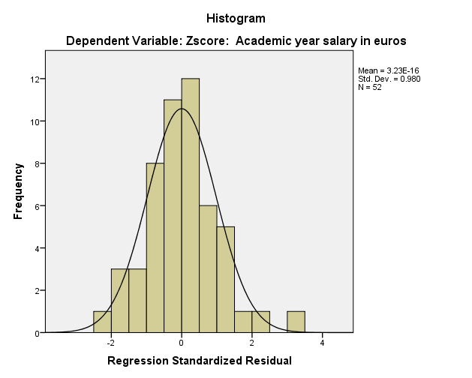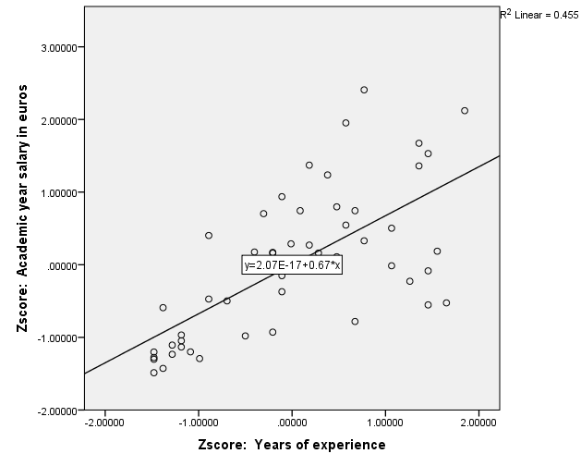 |  | 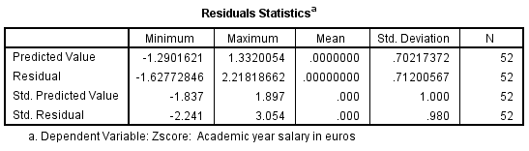

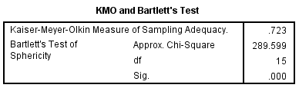  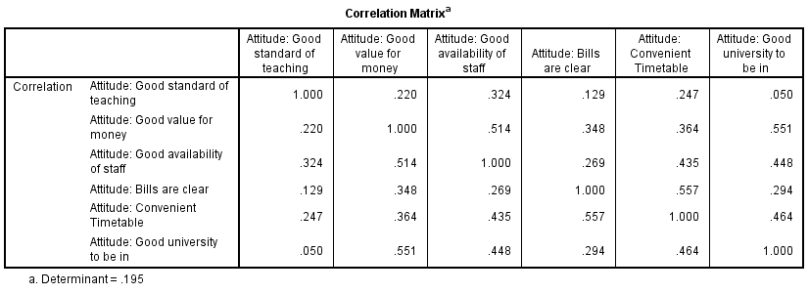 |  |  | 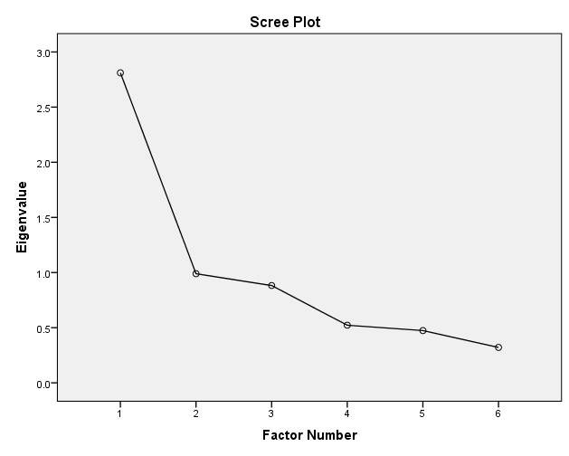
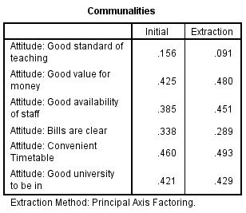 | 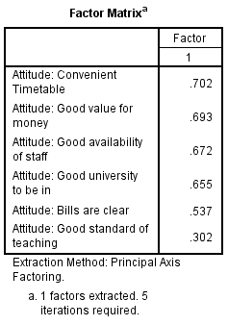
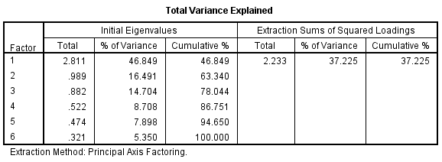 |  | 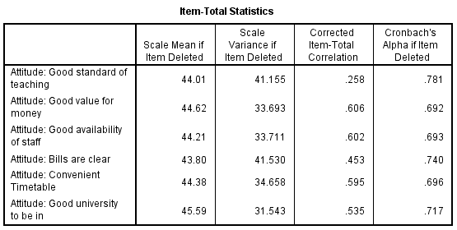
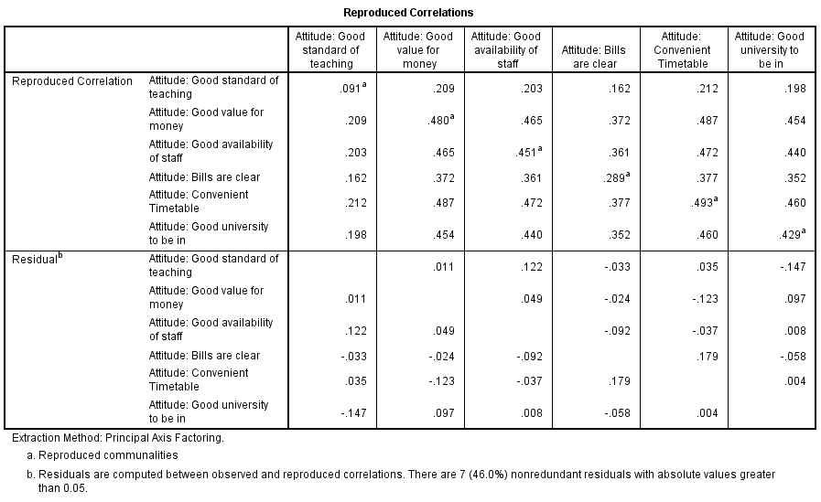 |  |  |  | 